E-File No. 3674
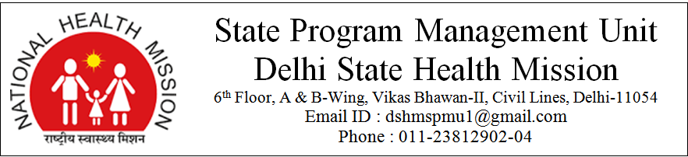
F. No. F1-13/7/2019-Estt./ Dated : 20/12/2019

Final result for the Post of “Accounts Assistant” for the interview held on 11th December-2019 at State Program Management Unit, Delhi State Health Mission, B-Wing, 6th Floor, Vikas Bhawan-II, Delhi-110054.

List of Selected Candidate for the post of Accounts Assistant
S.No | App. No. | Name of the Applicant | Father's Name / Husband's Name | Category
1 | 168 | Mr. Dharampal | Mr. Navrang | General
2 | 22 | Mr. Rajender Singh Bisht | Mr. Diwan Singh Bisht | General
3 | 159 | Mr. Piyush Mathur | Mr. Anil Mathur | General
4 | 11 | Mr. Sandeep Kumar | Mr. Jagmohan Vats | General
5 | 188 | Ms. Pooja | Mr. Sandeep Kumar | General
6 | 210 | Mr. Md. Amir Khan | Late Md. Akbar Khan | General
7 | 154 | Mr. Ashish Agrawal | Mr. Sanwar Mal Agrawal | General
8 | 118 | Mr. Manish Kumar | Mr. Nirankar Verma | OBC
9 | 222 | Mr. Mintu Kumar | Mr. Devender Singh | OBC
10 | 140 | Mr. Kunal | Mr. Man Singh | SC

All selected candidates for the post of Accounts Assistant are hereby directed to report at State Program Management Unit, Delhi State Health Mission, 6th Floor, B-Wing, Vikas Bhawan-II, Civil Lines, Delhi-110054 on 30th December-2019 at 10 AM for counseling.

-2-

List of Panel Candidate for the post of Accounts Assistant
S.No | App. No. | Name of the Applicant | Father's Name / Husband's Name | Category
1 | 138 | Mr. Harish Singh Rawat | Mr. Gopal Singh Rawat | General
2 | 169 | Mr. Ashu Rathore | Mr. Mukesh Rathore | General
3 | 148 | Mr. Neeraj | Mr. Khyali Ram | General
4 | 10 | Mr. Nikunj Sharma | Mr. Hemant Sharma | General
5 | 175 | Mr. Naveen Sharma | Mr. Rampal | General
6 | 124 | Mr. Ajay Kaushik | Mr. Jaipal Kaushik | General
7 | 109 | Mr. Kunal Kapoor | Mr. Naresh Kapoor | General
8 | 212 | Ms. Rinki Singh/ Kumari Rinki | Mr. Pramod Singh | OBC
9 | 75 | Ms. Sapna | Mr. Ram Khiladi | SC

List of panel candidates for the post of Accounts Assistant will be valid for two years from the date of publication of final result on website.

Sd/-
Mission Director
Delhi State Health Mission

